
Touchstones Project
Netcards

Prophetic Imperative Criminal Justice Netcards with Text

Antiracism HRJ
Black Lives Matter HRJ
Book Burning HRJ
Civil Rights HRJ

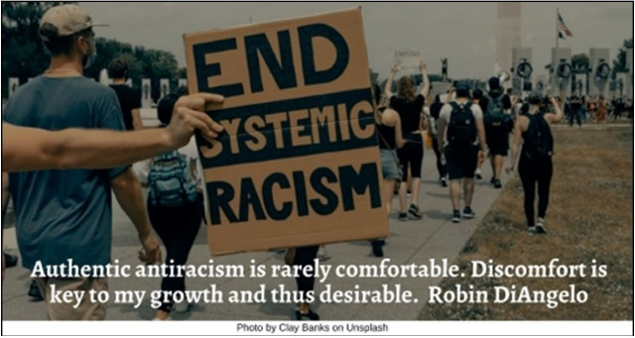

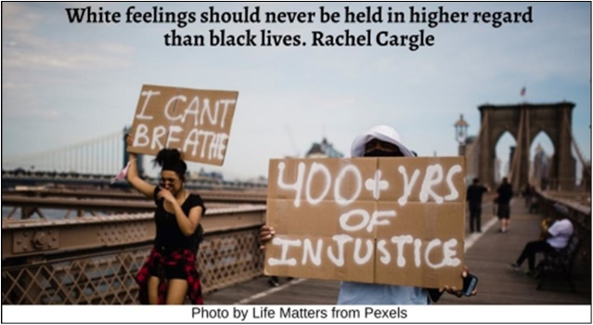

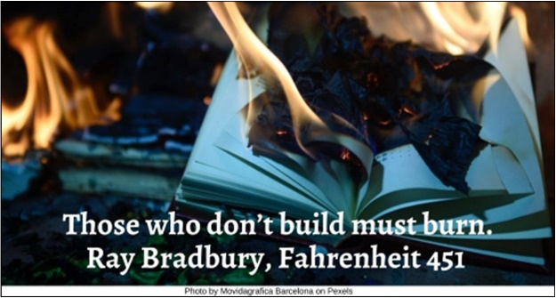

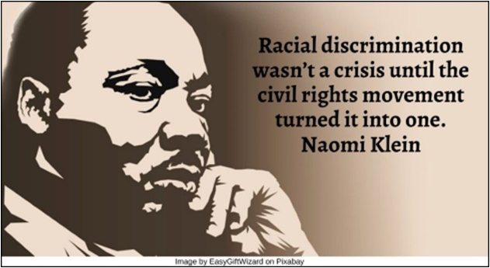
Criminal Justice HRJ
Democracy HRJ
Diversity HRJ
Economic Justice HRJ

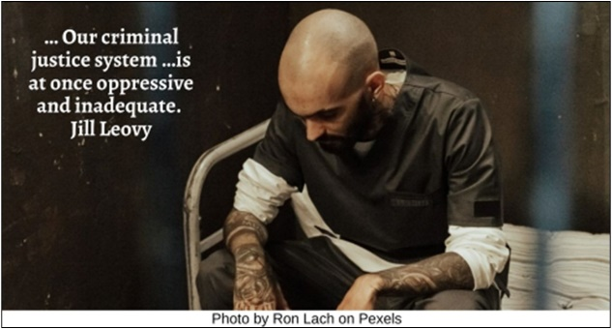

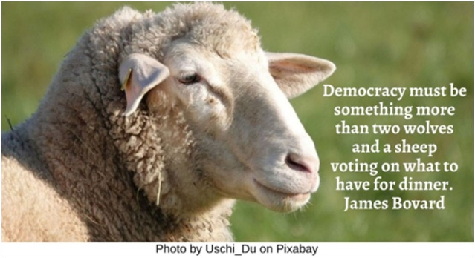

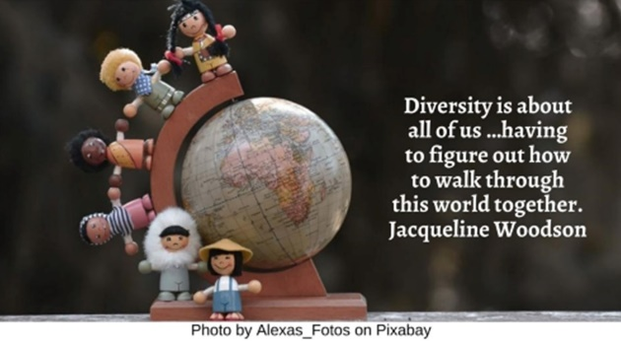

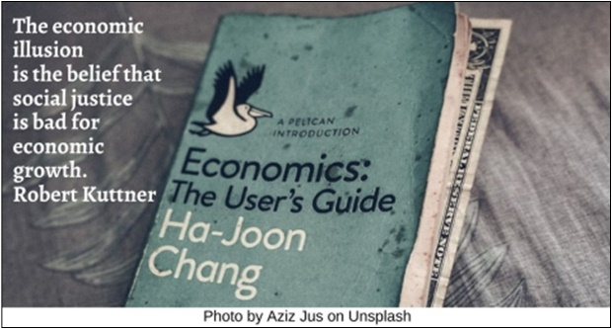
Ethical Eating HRJ
Freedom of Religion HRJ
Global Warming HRJ
Globalization HRJ

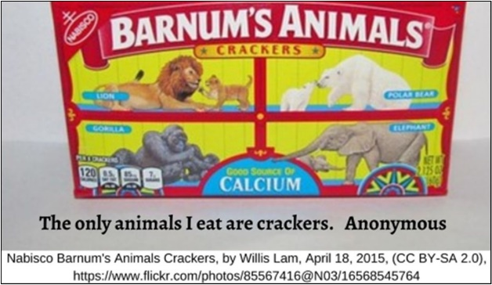

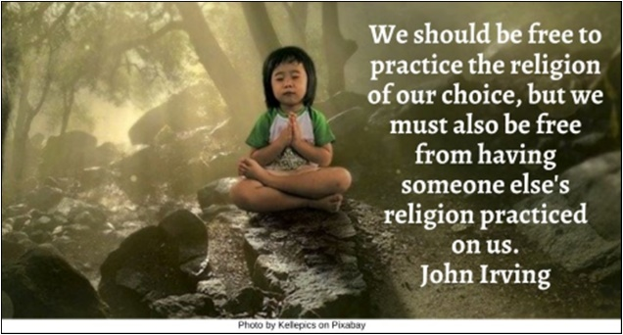

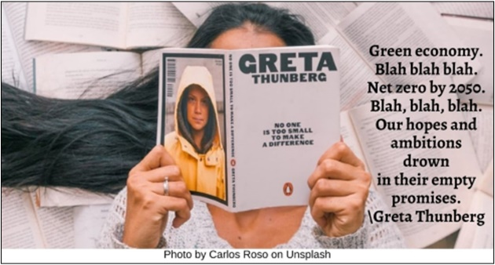

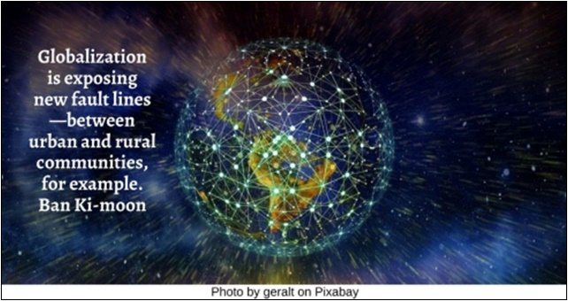

Gun Violence HRJ
Immigration HRJ
LGBTQ+ Rights HRJ
Living Wage HRJ

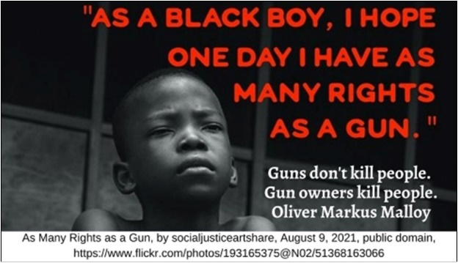

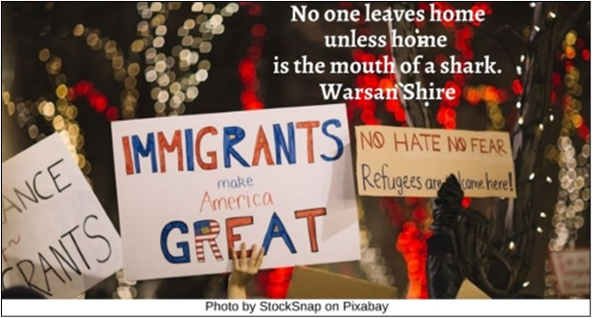

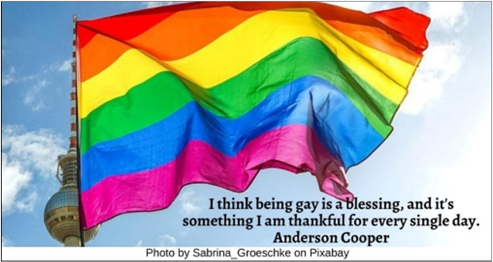

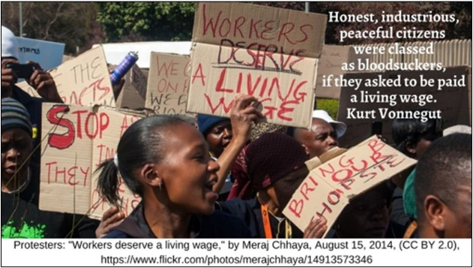

Marriage Equality HRJ
Moral Values HRJ
Nuclear Arms HRJ
Peacemaking HRJ

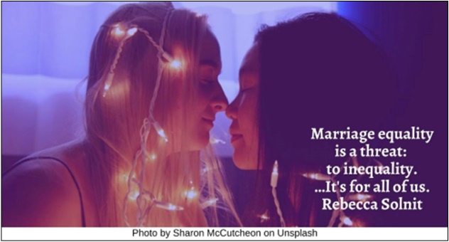

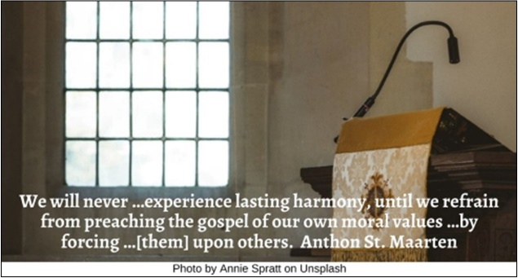

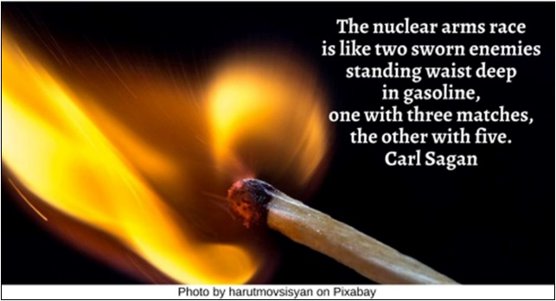

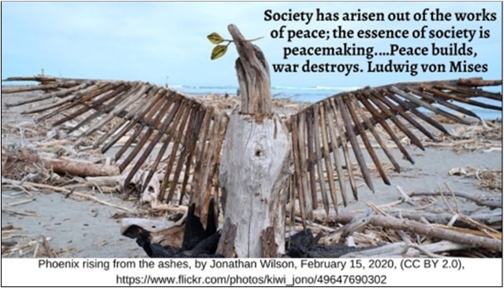

Pluralism HRJ
Prison Reform HRJ
Reproductive Freedom HRJ
Responsible Consumption HRJ

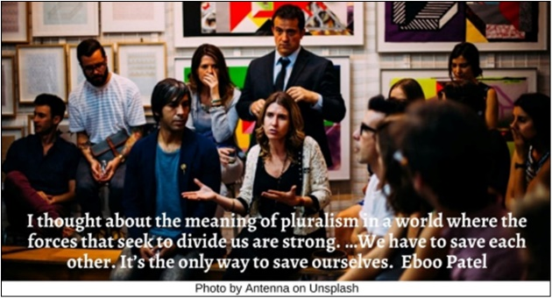

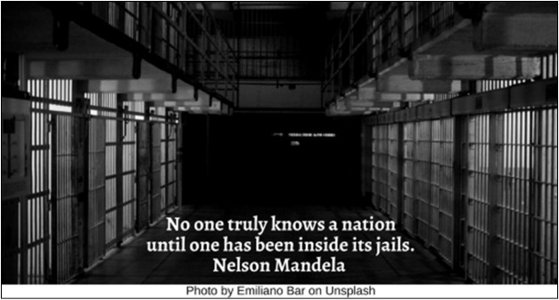

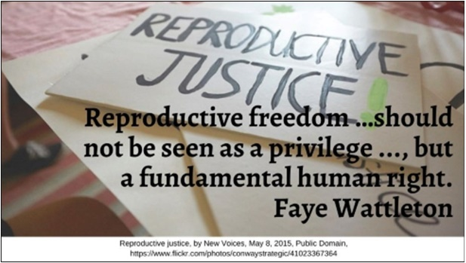

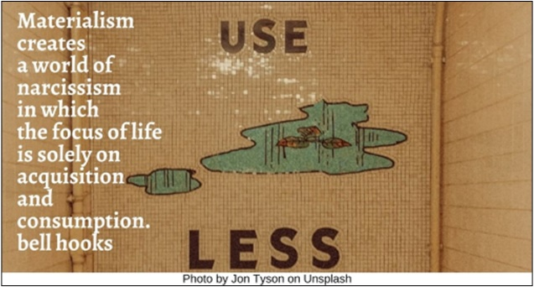

Science HRJ
Social Justice HRJ
Suffrage HRJ
Voting Rights HRJ

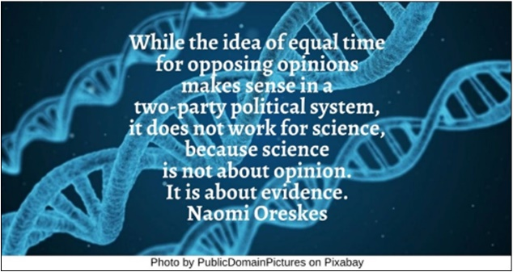

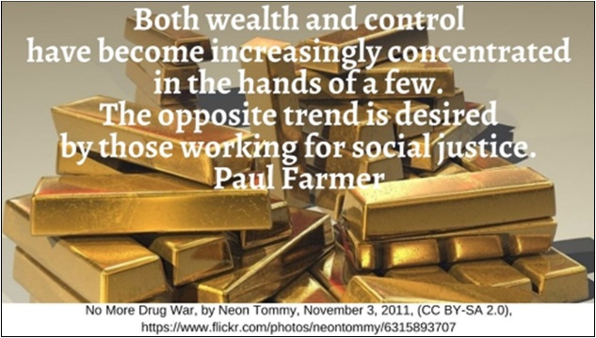

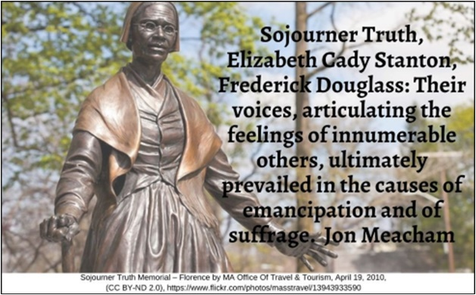

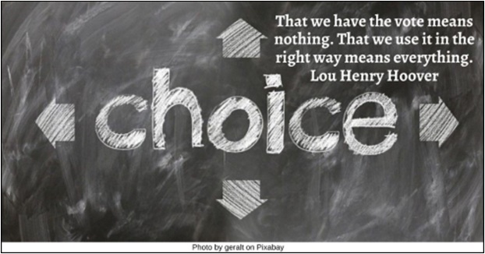

War on Drugs HRJ
White Supremacy HRJ
Worker’s Rights HRJ

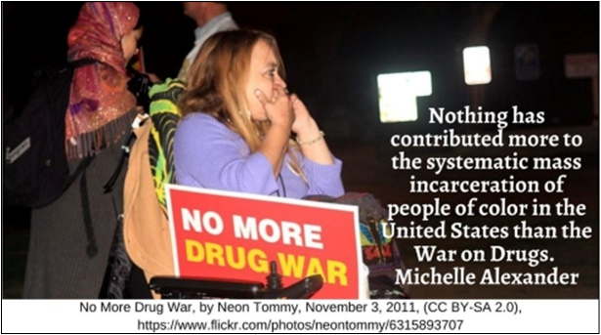

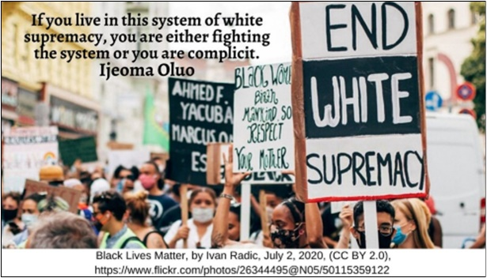

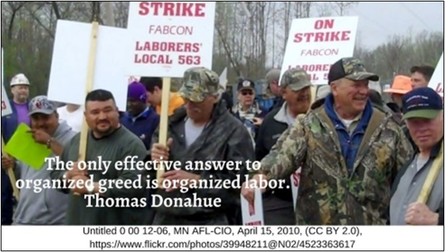

Text of Quotes
Antiracism HRJ
Authentic antiracism is rarely comfortable. Discomfort is key to my growth and thus desirable. Robin DiAngelo

Black Lives Matter HRJ
White feelings should never be held in higher regard than black lives. Rachel Cargle

Book Burning HRJ
Those who don’t build must burn.
Ray Bradbury, Fahrenheit 451

Civil Rights HRJ
Racial discrimination wasn’t a crisis until the civil rights movement turned it into one. Naomi Klein

Criminal Justice HRJ
… Our criminal justice system …is at once oppressive and inadequate. Jill Leovy

Democracy HRJ
Democracy must be something more than two wolves and a sheep voting on what to have for dinner. James Bovard

Diversity HRJ
Diversity is about all of us …having to figure out how to walk through this world together. Jacqueline Woodson

Economic Justice HRJ
The economic illusion is the belief that social justice is bad for economic growth. Robert Kuttner

Ethical Eating HRJ
The only animals I eat are crackers. Anonymous

Freedom of Religion HRJ
We should be free to practice the religion of our choice, but we must also be free from having someone else's religion practiced on us. John Irving

Global Warming HRJ
Green economy. Blah blah blah. Net zero by 2050. Blah, blah, blah. Our hopes and ambitions drown in their empty promises. Greta Thunberg

Globalization HRJ
Globalization is exposing new fault lines—between urban and rural communities, for example. Ban Ki-moon

Gun Violence HRJ
Guns don't kill people. Gun owners kill people. Oliver Markus Malloy

Immigration HRJ
No one leaves home unless home is the mouth of a shark. Warsan Shire

LGBTQ+ Rights HRJ
I think being gay is a blessing, and it's something I am thankful for every single day. Anderson Cooper

Living Wage HRJ
Honest, industrious, peaceful citizens were classed as bloodsuckers, if they asked to be paid a living wage. Kurt Vonnegut

Marriage Equality HRJ
Marriage equality is a threat: to inequality. …It's for all of us. Rebecca Solnit

Moral Values HRJ
We will never …experience lasting harmony, until we refrain from preaching the gospel of our own moral values …by forcing …[them] upon others. Anthon St. Maarten

Nuclear Arms HRJ
The nuclear arms race is like two sworn enemies standing waist deep in gasoline, one with three matches, the other with five. Carl Sagan

Peacemaking HRJ
Society has arisen out of the works of peace; the essence of society is peacemaking. …Peace builds, war destroys. Ludwig von Mises

Pluralism HRJ
I thought about the meaning of pluralism in a world where the forces that seek to divide us are strong. …We have to save each other. It’s the only way to save ourselves. Eboo Patel

Prison Reform HRJ
No one truly knows a nation until one has been inside its jails. Nelson Mandela

Reproductive Freedom HRJ
Reproductive freedom …should not be seen as a privilege or as a benefit, but a fundamental human right. Faye Wattleton

Responsible Consumption HRJ
Materialism creates a world of narcissism in which the focus of life is solely on acquisition and consumption. bell hooks

Science HRJ
While the idea of equal time for opposing opinions makes sense in a two-party political system, it does not work for science, because science is not about opinion. It is about evidence. Naomi Oreskes

Social Justice HRJ
Both wealth and control have become increasingly concentrated in the hands of a few. The opposite trend is desired by those working for social justice. Paul Farmer

Suffrage HRJ
Sojourner Truth, Elizabeth Cady Stanton, Frederick Douglass: Their voices, articulating the feelings of innumerable others, ultimately prevailed in the causes of emancipation and of suffrage. Jon Meacham

Voting Rights HRJ
That we have the vote means nothing. That we use it in the right way means everything. Lou Henry Hoover

War on Drugs HRJ
Nothing has contributed more to the systematic mass incarceration of people of color in the United States than the War on Drugs. Michelle Alexander

White Supremacy HRJ
If you live in this system of white supremacy, you are either fighting the system or you are complicit. Ijeoma Oluo

Worker’s Rights HRJ
The only effective answer to organized greed is organized labor. Thomas Donahue

